Intern Final Report

5/25/2015 – 9/18/2015



Hai Tang

Sep, 2015

[haitang@jhu.edu](mailto:haitang@jhu.edu)

937-238-3359



1 Introduction 1

2 Metrics for Filtered Raw EMG Signal 2

2.1 SNR 2

2.1.1 Basic Concepts 2

2.1.2 Code Implementation 2

2.2 Power Spectrum 3

2.2.1 Basic Concepts 3

2.2.2 Code Implementation 3

2.3 Inspection of Raw Baseline Noise 3

2.3.1 Baseline Noise 4

3 Human Forearm Experiments 5

3.1 General Preparatory Work 5

3.1.1 Skin Preparation 5

3.1.2 Find The Ideal Spot 5

3.1.3 Fix The Electrodes 6

3.1.4 Record EMG signal 6

3.2 Causes of Noises 6

3.2.1 Ambient Noise [1][2] 7

3.2.2 Transducer Noise [2] 14

3.2.3 Cross-Talk [2] 18

3.2.4 Motion Artifacts [1] 20

4 Simulation experiments 22

4.1 General Preparatory Work 22

4.1.1 Equipment and Software: 22

4.1.2 Setup Steps 22

4.2 Causes of Noises 23

4.2.1 Ambient Noise 23

5 Conclusion of Tests on Human Arm and Simulation 31

6 Code Changes On IBT Version D After Test Protocol Experiments 32

6.1 Cutoff Frequency Change on Butterworth High Pass Filter 32

6.2 Integral High Pass Filter 32

6.3 Large Spike Killer 33

6.4 Envelop 33

6.4.1 Methods 33

6.4.2 Metrics for Envelop Signal 36

6.4.3 Envelop Analysis Tools 37

6.5 Baseline Noise Removal 39

6.6 Digital to Analog Conversion 39

6.7 Transmit Envelop 40

7 Open Questions 41

7.1 The Causing of Large Spikes 41

7.2 White Noise When IBT Version D Electrode Not Attaching Skin 41

7.3 How to Design the Game for Mechanical Hand 41

7.4 Metrics Design for Envelop Signal Analysis 42

7.5 Experiment Design 42

8 Future Works 43

8.1 Find out the source of large spikes and solve it 43

8.2 Find out the reason of white noise and solve it 43

8.3 Finish the human tests for EMG Game 44

8.3.1 Possible Publication 44

8.4 Design a game for mechanical hand experiments 44

8.4.1 Possible Publication 44

9 Where and How to Find Pre-saved Test Data and Literatures 45

10 References 46

Appendix 47

10.1 Embedded C Codes 47

10.1.1 Block Diagram 47

10.1.2 Source Code Location 48

10.1.3 Key Functions Explanation 48

10.2 C# Game Codes 49

10.2.1 Block Diagram 49

10.2.2 Key Function Descriptions 50

10.2.3 Where Are The Game Data Saved 51

10.2.4 Source Code Location 51

10.3 MATLAB Codes 52

10.3.1 hai_emg_daq_general.m 52

10.3.2 ManualSNR_v2.m 53

10.3.3 hai_emg_daq_envelop.m 54

10.3.4 hai_MeasureAll.m 54

1. Introduction

EMG signal is stochastic in nature and can be reasonably represented by a Gaussian distribution function. The amplitude of EMG signal can range from 0 to 10 mV (peak to peak). And the usable energy of the signal is limited to the 0 – 500 Hz frequency range, with the dominant energy being in the 50 - 150 Hz range [1].

The test protocol in section 2 to section 5 aims to evaluate the effect of different sources of noises on the Filtered Raw EMG Signal quality of the IBT electrode attached to human forearm and connected to the EMG simulator. And also aims to compare the performance with other electrodes like OttoBock, LTI, and IBT Version B etc.

Section 6 summarizes the works done after the raw EMG experiments, and transfers the focus to EMG envelope.

Section 7 to 9 discussed some key open question and the future works, as well as how to deal with the experimental data retrieval.

The Appendix includes all the detailed explanations of the Embedded C Code, the C# Game Code and related Matlab code.

1. Metrics for Filtered Raw EMG Signal

In order to quantify the quality of obtained EMG signals in both amplitude and frequency perspectives, two metrics are introduced, respectively SNR and Power Spectrum. And then the general inspections on EMG raw signal are discussed.

* 1. SNR
     1. Basic Concepts

Signal to noise ratio (SNR) is the ratio of energy in the EMG signal to the energy in the noise signal. In general, noise is defined as electrical signals that are not part of the desired EMG signal [1].

* + 1. Code Implementation

A function in MATLAB named “ManualSNRv2” (refer to 10.3.2 for details) is called to calculate SNR of the obtained filtered EMG signal (time length of the measured EMG signal is user selected). The length of a valid EMG signal and noise signal is firstly selected, and then select the starting points of 3 (or user selected) representative clean EMG signals and 3 (or user selected) representative stable noise signals to calculate the average SNR based on the amplitude of signals.

* 1. Power Spectrum
     1. Basic Concepts

Power spectrum is a representation of the magnitude of the various frequency components of a signal, which answers the question of “how much power is contained in the frequency components of the signal” in the form of a distribution of power values as a function of frequency. The power is considered to be the average of the square of signal, which is the square of FFT’s magnitude in frequency domain. By performing spectral analysis, some important features of signals can be discovered that are not obvious in the time waveform of the signal.

* + 1. Code Implementation

In the program named “hai_emg_daq_general.m” (refer to 10.3.1 for details), the Fast Fourier Transformation (FFT) is applied to the obtained n-second long (n is user selected) piece of EMG signal to analyze its frequency components. And then the power spectrum is calculated and plotted.

* 1. Inspection of Raw Baseline Noise

The visual inspection of the raw EMG baseline is an important step at the beginning. The magnitude of settled raw EMG signal with electrode IBT D Version is typically around 400 to 500 for the positive part of peaks (i.e. 800-1000 peak to peak). The unit is probably in microvolt, but has not been verified yet. To verify the unit should be one of the things need to be done in the near future (8.1).

* + 1. Baseline Noise

A completed noise-free recording is impossible: according to [4], small amplitude spikes or random nature may be visible but should not exceed 10-15 microvolts. The average noise level should be at 1 (excellent) to 3.5 microvolts. But in our case, we consider noise magnitude around 400 as low noise level for Version D IBT electrodes, after settling. And the corresponding FFT has about -70dB in low frequency part (<10 Hz).

1. Human Forearm Experiments
   1. General Preparatory Work
      1. Skin Preparation

Wipe the target spot with an alcohol cloth. And also wipe the reference location on skin. Wait for a few seconds or up to a few minutes for electrode to be settled.

Note: This step excludes the transducer noise test in section 3.2.2.1, which require different preparatory materials.

* + 1. Find The Ideal Spot

We can use Biosim to find the ideal spot on the arm with strongest EMG signal in real time. Specifically, the ideal electrode site spot is identified using an OB electrode, i-Limb, and Touch Bionics’s biosim software. The electrode is moved to various locations on the forearm. In the meanwhile the subject holds a green handled grip strengthener in his dominant hand and flexes several times until the target ideal spot is found and marked.

Or alternatively, we can use the Hai_Game software to do the same job. Just click Start Display and move around the electrode to find the spot with strongest signal.

* + 1. Fix The Electrodes

Put the IBT electrode on target spot and use a gel cuff (Ohio WillowWood) with proper tension to wrap around the forearm to fix the electrodes. The reference dome electrode was mounted on the cuff on the opposite side of the forearm near a bone or less muscular area.

Update: We can use the orange cloth cuff, which is easier to wear. And since IBT Version D electrodes have the reference in between the two measuring metal bars, just put the whole Version D electrode onto the target spot.

* + 1. Record EMG signal

EMG signal is recorded from IBT’s electrode using IBT’s custom-made DAQ and MATLAB. The function named “hai_emg_daq_general.m” (with time parameter: 12s, refer to 10.3.1 for details) is run and the subject closes the grip strengthener for 3 times per trial of EMG recording, which lasts for 12 seconds. The subject flexes for 1 second, and keeps the arm totally relax for a few seconds, repeat for 3 times (follow the flex and relax instructions in MATLAB window).

* 1. Causes of Noises

Node: Abs Control in the graphs mean absolute control condition, with the power lines of power noise sources unplugged if there are any (in the control experiments, the noise sources are not nearby but are plugged, which still introduces a small amount of noise). The subject is not touching or near any noise sources.

* + 1. Ambient Noise [1][2]

Note: The ambient noise signal may have amplitude that is 1-3 orders of magnitude greater than the EMG signal [1].

* + - 1. Power Line Radiation [1] [2]

Purpose: To evaluate the effect of power line radiation (50 or 60 Hz) on the signal quality of the electrodes.

In each test case below, complete the EMG collection procedure as described in section 3.1.4.

1. Put a computer power cable (adaptor input 110V, 1A, 50-60Hz, output 14.85V, 3.05A) near the target spot area, with a distance of 1 cm. Cable orientation: parallel with the arm.
2. Touch a laptop power cable with the other hand.
3. Touch a laptop power cable with feet (wearing shoes).
4. Touch a telephone power cable (adaptor input 110V, 0.5A, 50-60Hz, output 48V, 0.38A) with feet (wearing shoes).

Control: Repeat the experiment without touching or having any power cable nearby.

**Figure 3.1: Testing Result for Power Line Radiation**

* + - 1. Cell Phone Radiation

Purpose: To evaluate the effect of cell phone radiation on the signal quality of the electrodes.

In each test case below, complete the EMG collection procedure as described in section 3.1.4.

1. Put a cellphone near the target spot area, with 1cm distance. The back (metal) side facing the electrodes.
2. Put a cellphone near the target spot area (1 cm distance), make phone calls and receive phone calls.
3. Put a cellphone near the target spot area (1 cm distance) and surfing the Internet with WIFI.
4. Repeat case 3 with LTE instead of WIFI.
5. Put a cellphone near the target spot area (1 cm distance) and use GPS service by opening the map and loading directions to a certain destination.

Control: Repeat the experiment without any cellphones nearby.

**Figure 3.2: Testing Result for Cell Phone Radiation**

* + - 1. Incandescent Light Bulb Radiation [1]

Purpose: To evaluate the effect of incandescent light bulb radiation on the signal quality of the electrodes.

Note: The specifications of the incandescent light bulb used in this test are 57W, 120V, in soft white color.

In each test case below, complete the EMG collection procedure as described in section 3.1.4.

1. Put the incandescent light bulb near the target spot area, with a distance of 1cm.
2. Put the incandescent light bulb near the target spot area as above and switch on and off. Keep off for the first flex, turn on before the 2nd flex, and turn off before the 4th flex.

Control: Repeat the experiment without any incandescent light bulb near target spot area.

**Figure 3.3: Testing Result for Incandescent Light Bulb Radiation**

* + - 1. Fluorescent Lamp Radiation [1]

Purpose: To evaluate the effect of fluorescent lamp radiation on the signal quality of the electrodes.

Note: The fluorescent lamp used in this test is 22W, in white color.

In each test case below, complete the EMG collection procedure as described in section 3.1.4.

1. Put the fluorescent lamp near the target spot area, with a distance of 1cm.
2. Put the fluorescent lamp near the target spot area, keep it on, turn it off and then make it start again.

Control: Repeat the experiment without any fluorescent lamps near target spot area.

**Figure 3.4: Testing Result for Fluorescent Lamp Radiation**

* + - 1. Compact Fluorescent Light (CFL) Radiation

Purpose: To evaluate the effect of compact fluorescent light radiation on the signal quality of the electrodes.

Note: The fluorescent lamp used in this test is 45W, 110-130V, 50/60 Hz, 5500K and in white color.

In each test case below, complete the EMG collection procedure as described in section 3.1.4.

1. Put the CFL near the target spot area, with a distance of 1cm.
2. Put the CFL near the target spot area, keep it on, turn it off and then make it start again.

Control: Repeat the experiment without any fluorescent lamps near target spot area.

**Figure 3.5: Testing Result for CFL Radiation**

* + - 1. Fan Disturbance [3]

Purpose: To evaluate the effect of fan disturbance on the signal quality of the electrodes.

Note: The fan used in this test is Holmoes 4’’ metal fan HNF0410 with 120VAC, 60Hz, 13W.

In each test case below, complete the EMG collection procedure as described in section 3.1.4.

1. Put a fan near the target spot area with a distance of 1 cm to the outer frame of the fan, the front side of the fan faces electrodes, and keep the fan on.
2. Repeat with the back side facing the electrodes
3. Keep fan off for the 1st flex, turn on before the 2nd flex, and turn off before the 4th flex

Control: Repeat the experiment without any fans near target spot area.

**Figure 3.6: Testing Result for Fan Disturbance**

* + - 1. Router Radiation

Purpose: To evaluate the effect of router radiation on the signal quality of the electrodes.

Note: The router used in this test is TRENDnet TEW-812DRU.

In each test case below, complete the EMG collection procedure as described in section 3.1.4.

1. Put a working router near the target spot area, with a distance of 1cm from the side of router.

Control: Repeat the experiment without any routers near target spot area.

**Figure 3.7: Testing Result for Router Radiation**

* + 1. Transducer Noise [2]
       1. D/C Voltage Potential [2] (Settling Time)

Purpose: To evaluate the effect of D/C voltage potential on the signal quality of the electrodes.

Note: This kind of noise is caused by differences in impedance between skin and the electrode sensor. The test cases are designed as repeating the EMG recoding process once per minute for about 40 minutes, and find out the settling time under different skin conditions. Subjects being tested may only complete one test case during one day.

1. Cover the target area with water
2. Cover the target area with alcohol

Control: Repeat experiment without anything covering target spot

**Figure 3.8: Settling time under different skin conditions**

**Figure 3.9: Settling time for each electrode**

* + 1. Cross-Talk [2]

Purpose: To evaluate the effect of cross-talks on the signal quality of the electrodes.

Note: With smaller muscles the electrodes may overlook the electrical activity of one or more neighboring muscles and their signals may crosstalk with the EMG from the desired muscle. While signal sources close to the electrode will dominate the recorded EMG signal, more distant sources from other muscles may experience crosstalk[2]. Phase difference between flexion and extension signal suggests no cross-talk between two EMG signals, and overlapping means possible cross-talk.

Hand motion:

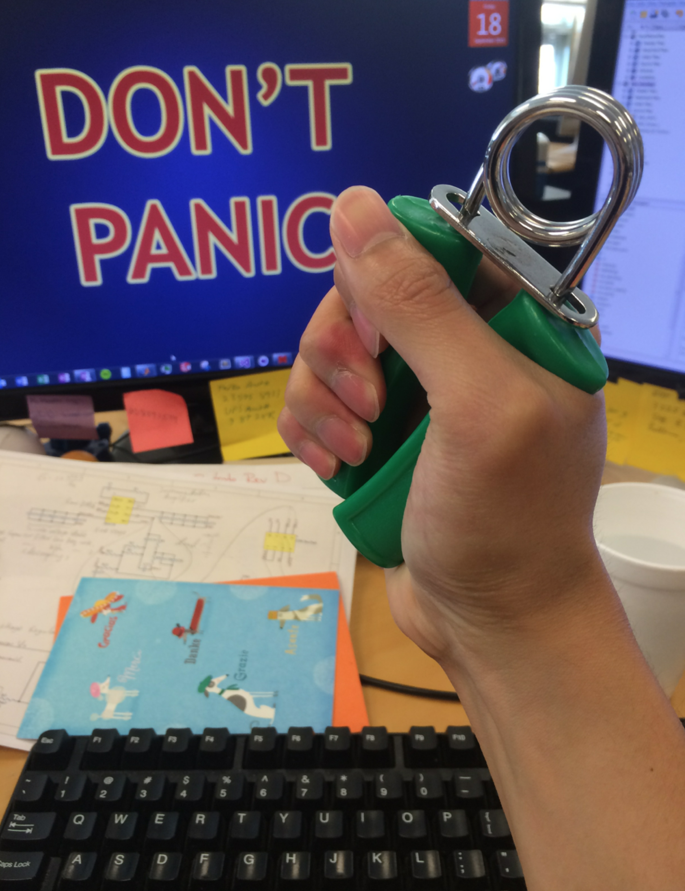 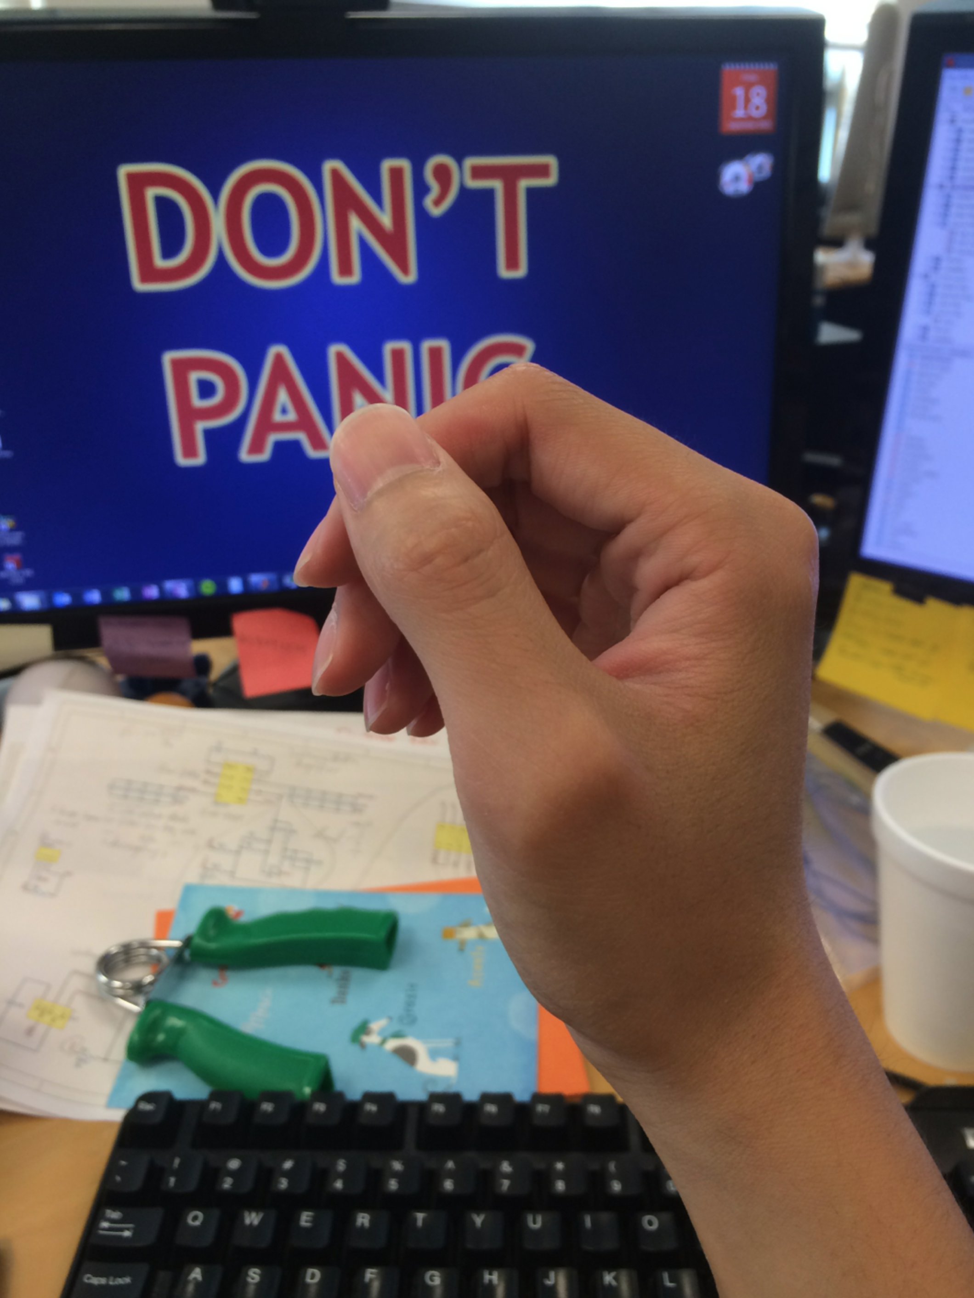 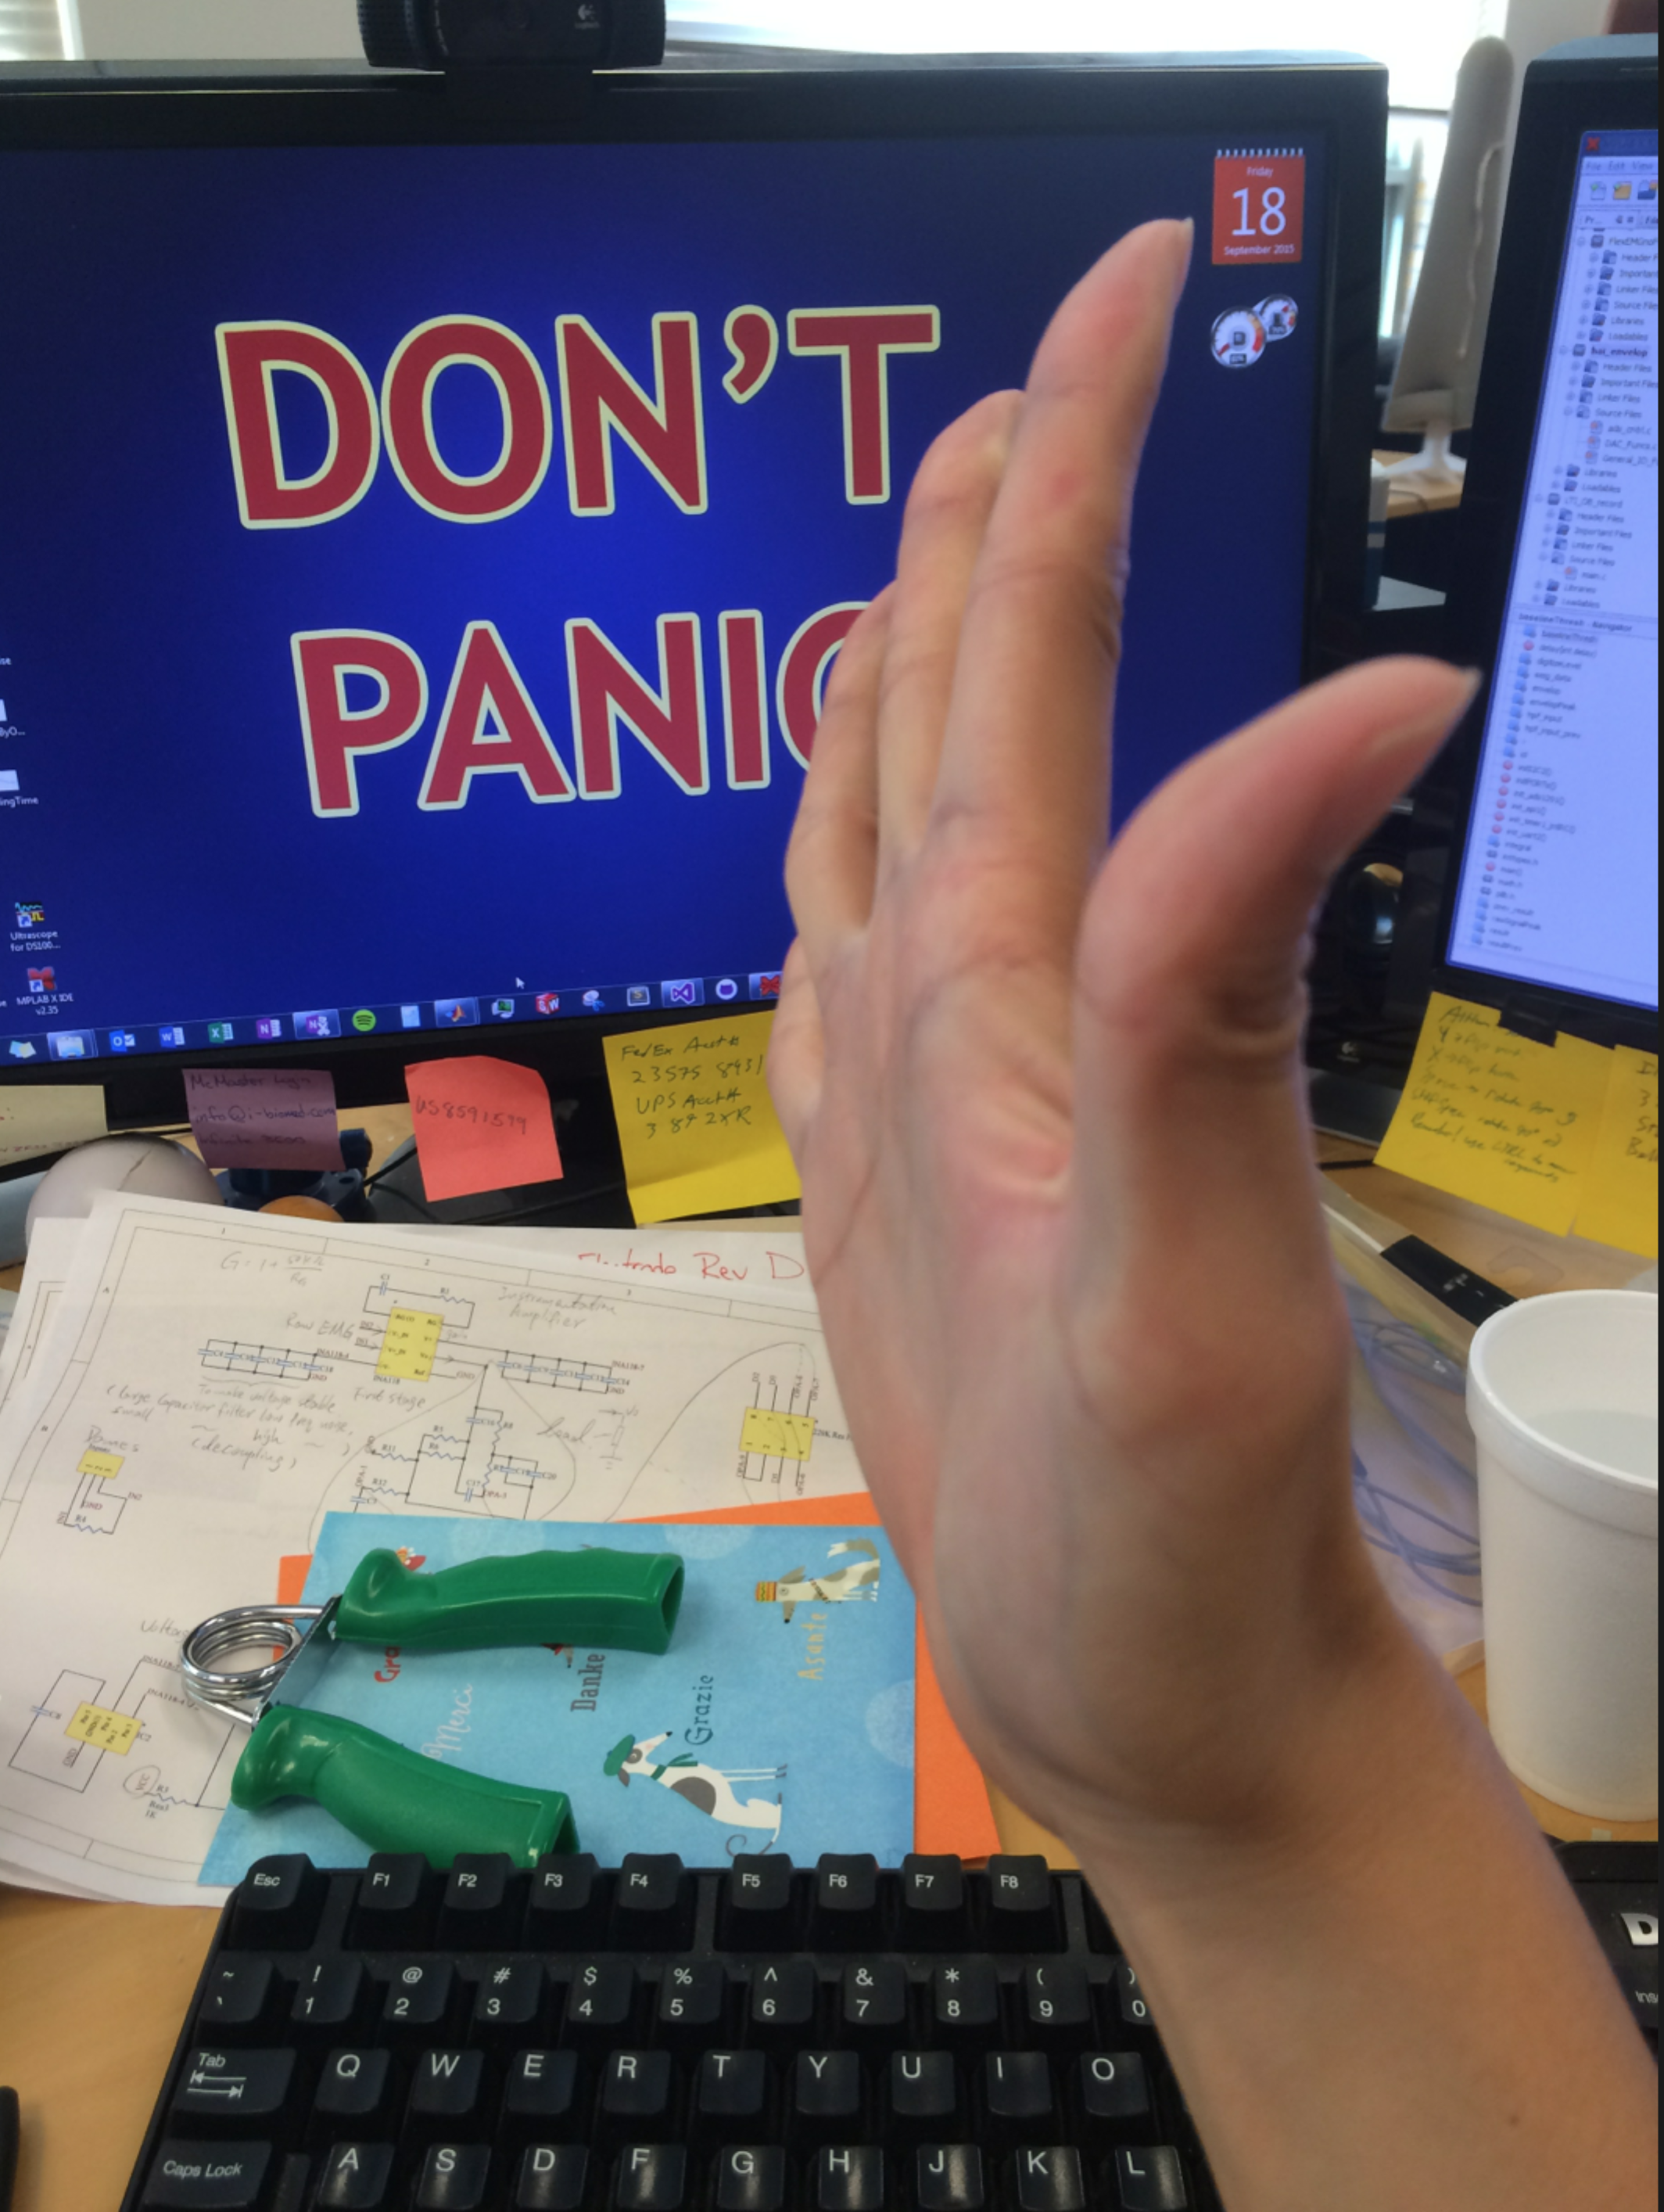

**Figure 3.10: Flextion, Relax and Extension**

1. Test with different muscle (flex muscle and extension muscle) being activated and observe the cross-talk signal on EMG plot. The extension muscle is active by fully stretch the palm to the opposite direction of doing flexing. Do flex-relax for 4 times and then stretch-relax for 4 times. Then SNRe is calculated by averaging the SNR of extension EMG signal, and SNRf is calculated by averaging the SNR of flexing EMG signal, both of them have the same pure noise signal used for SNR calculation.

**Figure 3.11: Cross Talk SNR_noise vs. SNR_signal**

**Figure 3.12: Cross Talk SNR Ratio = SNR_signal / SNR_noise**

Note: The SNRe is consistently larger then SNRf for OttoBock in this case, which is abnormal. It is because the contact (wet) of reference in this specific experiment setup is not consistent with the other two contacts (dry), which makes the cross talk signal very large. So the result of Ottobock is not very trustable.

* + 1. Motion Artifacts [1]
       1. Motion Between Detection Surface

Purpose: To evaluate the effect of D/C voltage potential on the signal quality of the electrodes.

Note: The detection surface is the interface between electrode and skin.

1. A hand bike is used for this motion artifact experiment. The right hand of the subject is attached to the right handle of the band bike using the white bandage. And the hand is totally relaxed without applying any force when relaxed. Then use the left hand to rotate the left handle with a fixed rpm, which is 15 rpm (so that in there will be 3 cycles in 12s). In the meanwhile, perform flexing and relaxing for three times. Do the flexing every time when the handle comes to the lowest position of one rotation. Observe any possible spikes or other noises.

Control: Repeat experiment with the right hand attached to the right handle but not rotating the hand bike. And the right handle should be set to the lowest location of one rotation.

**Figure 3.13: Testing Result for Motion Artifacts**

1. Simulation experiments

Purpose: To evaluate the signal quality of electrodes with simulated EMG signal while exposed to different kinds of ambient noises. And also compare the experiment results with actual human forearm.

* 1. General Preparatory Work
     1. Equipment and Software:

1. CX Development Board (v2)
2. DC Power Supply (MASTECH HY3005F-E)
3. Wires and Clippers
4. IBT Version D electrode
5. Other electrodes: Ottobocks, LTI, IBT Version B
6. Computer with MATLAB
   * 1. Setup Steps
     2. Plug in the IBT electrode (B2) to corresponding pins on breadboard
     3. Power on the CX Development Board (v2) with DC power supply using a value of 7.3V

Note: In the future we have decided to use 3.3V power supply for the electrode itself instead of 7.3V.

* + 1. Use wires and clippers to connect the two electrodes with dummy EMG input: one electrode connects with dummy EMG signal output, and the other one connects the ground.
    2. Record EMG signal: EMG signal is recorded from IBT’s electrode using IBT’s custom-made DAQ and MATLAB. The function named “hai_emg_daq_general.m” (refer to 10.3.1 for details) is run with the inputted time period of 12s.
  1. Causes of Noises
     1. Ambient Noise
        1. Power Line Radiation

Purpose: To evaluate the effect of power line radiation (50 or 60 Hz) on the signal quality of the electrodes in simulation.

1. Put a computer power cable (adaptor input 110V, 1.5 A, 50-60Hz, output 20V, 4.25A max) near the electrode, with a distance of 1 cm. Cable orientation: vertically across two electrode bars.
2. Repeat with the power cable near the extended wire for electrodes (1 cm for distance)

Control: Repeat the experiment without touching or having any power cable nearby.

**Figure 4.1: Test Results for Power Line Radiation**

* + - 1. Cell Phone Radiation

Purpose: To evaluate the effect of cell phone radiation on the signal quality of the electrodes.

1. Put a cellphone near the electrodes, with 1cm distance. The back (metal) side facing the electrodes.
2. Put a cellphone near the target spot area (1 cm distance), make phone calls and receive phone calls.
3. Put a cellphone near the target spot area (1 cm distance) and play an online video with WIFI.
4. Repeat case 3 with LTE instead of WIFI.
5. Put a cellphone near the target spot area (1 cm distance) and use GPS service by opening the map and loading directions to a certain destination.

Control: Repeat the experiment without any cellphones nearby.

**Figure 4.2: Test Results for Cell Phone Radiation**

* + - 1. Incandescent Light Bulb Radiation

Purpose: To evaluate the effect of incandescent light bulb radiation on the signal quality of the electrodes.

Note: The incandescent light bulb used in this test is 57W, 120V, in soft white color.

1. Put the incandescent light bulb near the electrodes with a distance of 1cm.
2. Repeat with the power cable near the extended wire for electrodes (1 cm for distance)

Control: Repeat the experiment without any incandescent light bulb near target spot area.

**Figure 4.3: Test Results for Incandescent Light Bulb** **Radiation**

* + - 1. Fluorescent Lamp Radiation

Purpose: To evaluate the effect of fluorescent lamp radiation on the signal quality of the electrodes.

Note: The fluorescent lamp used in this test is 22W, in white color.

1. Put the fluorescent lamp near the electrodes, with a distance of 1cm.
2. Repeat with keeping pressing the switch button.
3. Repeat with the power cable near the extended wire for electrodes (1 cm for distance)

Control: Repeat the experiment without any fluorescent lamps near target spot area.

**Figure 4.4: Test Results for Fluorescent Lamp** **Radiation**

* + - 1. Compact Fluorescent Light (CFL) Radiation

Purpose: To evaluate the effect of compact fluorescent light radiation on the signal quality of the electrodes.

Note: The fluorescent lamp used in this test is 45W, 110-130V, 50/60 Hz, 5500K and in white color.

1. Keep CFL on. Put the CFL near the electrodes, with a distance of 1cm.
2. Repeat with the power cable near the extended wire for electrodes (1 cm for distance)

Control: Repeat the experiment without any fluorescent lamps near electrodes.

**Figure 4.5: Test Results for CFL** **Radiation**

* + - 1. Fan Disturbance

Purpose: To evaluate the effect of fan disturbance on the signal quality of the electrodes.

Note: The fan used in this test is 120V, 60Hz, 13W, with 5A fuse.

1. Put a fan near the electrodes with a distance of 1 cm to the outer frame of the fan, the front side of the fan faces electrodes, and keep the fan on.
2. Repeat with the back side facing the electrodes
3. Keep fan off for the 1st burst of signal, turn on before the 2nd burst of signal, and turn off before the 4th burst of signal

Control: Repeat the experiment without any fans near the electrodes.

**Figure 4.6: Test Results for Fan Disturbance**

* + - 1. Router Radiation

Purpose: To evaluate the effect of router radiation on the signal quality of the electrodes.

Note: The router used in this test is TRENDnet TEW-812DRU.

1. Put a working router near the electrodes, with a distance of 1cm from the top of router.
2. Put a working router near the electrodes, with a distance of 1cm from the side of router.

Control: Repeat the experiment without any routers near the electrodes.

**Figure 4.7: Test Results for Router Radiation**

1. Conclusion of Tests on Human Arm and Simulation

From the comparisons between skin tests and simulation tests, and the comparison among different electrodes (please refer to Test Protocol Data with Filter.xlsx for details like raw recordings and figures), we can come to the conclusion that IBT Version D electrode has the best performance: highest SNR values (only LTI has higher value in simulation due to its noise elimination mechanism, and we care more on human arms), negligible effects from large power noise, and very stable performance under all kinds of conditions.

1. Code Changes On IBT Version D After Test Protocol Experiments

All the code changes are made on Embedded C code file named ads_cntrl.c under hai_envelop project.

It seems there is no low pass filter in the code, but judging from the plotted EMG signal graph, a 500Hz cutoff can be easily seen.

* 1. Cutoff Frequency Change on Butterworth High Pass Filter

The cutoff frequency of the first order Butterworth filter is increased from 3.33Hz to 10Hz. The following cutoff values are compared: 3.33Hz, 10Hz, 20Hz, and 30Hz. After comparing the overall performance (taken the integral filter into consideration, which will be discussed later), 10Hz cutoff frequency is chosen, since it significantly reduces the noise in low frequency (<10Hz), while not losing useful information (>10Hz).

* 1. Integral High Pass Filter

The integral high pass filter is used to further remove low frequency noises like baseline drift, upon the result from the Butterworth high pass filter. This filter calculates and remembers the integral of EMG values before the current data point, the closest data points have larger effect on the integral value. Then subtract the integral value from the current EMG result value, to make sure the EMG data are centered at zero.

The equation of integral high pass filter:



* 1. Large Spike Killer

This is a temporary solution to minimize the effect of unexpected large spikes. When the EMG raw data is larger than the pre-set spike cutoff value, then set the EMG value to the pre-set raw signal peak value. Similarly when the EMG raw data is smaller than negative spike cutoff value, then set the EMG value to negative raw signal peak value.

Currently the preset spike cutoff value and raw signal peak value are both 20k, for gain = 6 (default).

In the future when the real causing of large spikes is found and solved, we can then get rid of the large spike killer.

* 1. Envelop
     1. Methods
        1. Moving Average

Based on a user defined time window, a certain amount of data is averaged using the sliding window technique. Since we need to rectify the EMG signal before calculating the average, it is also called the Average Rectified Value (ARV) and serves as an “estimator of the amplitude behavior” (SENIAM). It relates to information about the area under the selected signal epoch.[4]

* + - 1. Root Mean Square (RMS) – Chosen Method

Similar to the Moving Average method, it is defined for a certain epoch (time window) and typically in kinesiological studies, time duration of 20ms (fast movements like jump, reflex studies) to 500ms (slow or static activities) are selected. A value that works well in most conditions is between 50 and 100ms. The higher the time window is selected, the higher the risk of a phase shift in contractions with steep signal increase needs to be considered (see red rectangle in Fig. XX). [4]

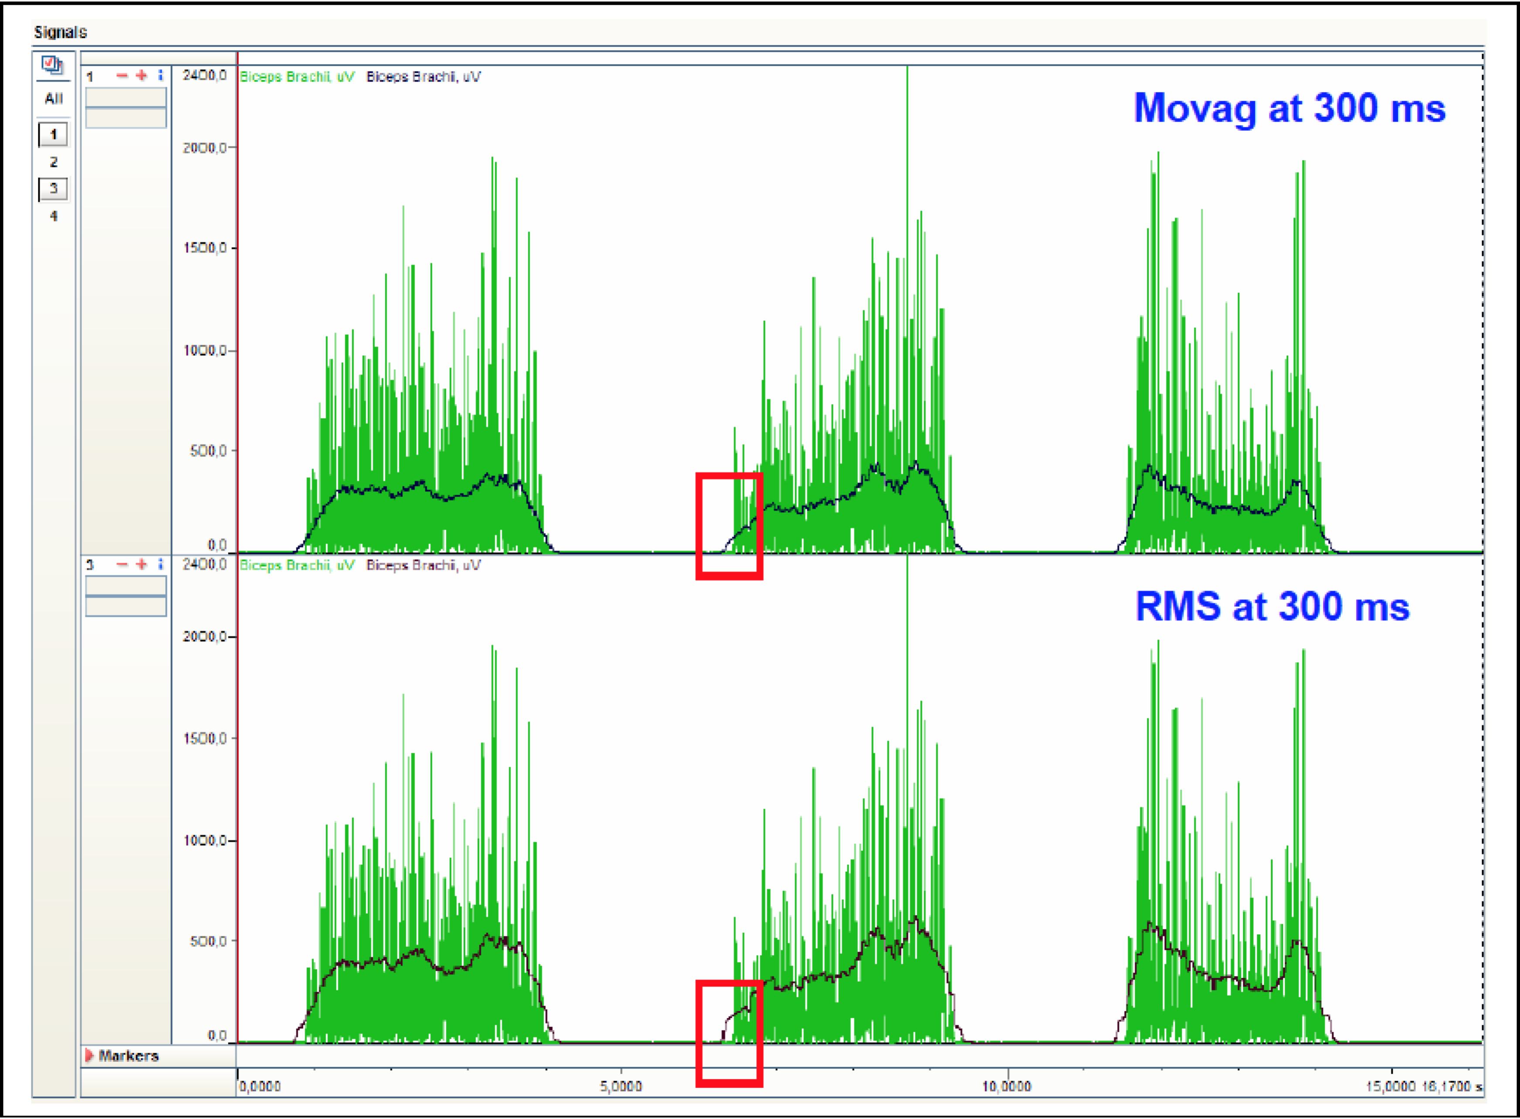

**Figure 6.1: Comparison of two smoothing algorithms using the same window width: Being very similar in shape, the RMS algorithm (lower trace) shows higher EMG amplitude data than the Moving Average (upper trace)** [4]

From our own experiments, we found that 100ms (or smaller, like 64ms) window size works very well when we need to perform quick signal commands, such as three-taps. The quick taps can be clearly separately. The off is that shorter window length has larger variance, which leads to more difficult control experience.

In the meanwhile, 400ms window length works the best when we want to keep the signal in a certain level for a certain time period. It has less variance thus is the easiest to control. The off is longer rising time, and sometimes large overshoot are introduced at the beginning of contraction.

The Root Mean Square Method is finally chosen through both experimental testing and literature review for our IBT electrode for at least two reasons:

1. If the signal values are normal random deviates, then the RMS approach can be shown to be an optimal method for estimating the standard deviation of the underlying normal distribution.

2. If the signal were a voltage applied across a resistor, the mean square method correctly predicts the power (heat) that will be dissipated in the resistor - which has an intuitive appeal as a measure of "strength of signal".

3. It is recommended by a lot of literatures including [4].

* + - 1. Weighted Parameters

This method needs only one line of code:

envelop = 0.99*envelop+0.01*result;

Where 0.99 and 0.01 are two changeable weight parameters that sum up to 1. This method is not chosen since it has larger variance than the other two methods.

* + 1. Metrics for Envelop Signal
       1. Rising Time

The time period from the beginning of a contraction to the signal goes to the first peak of this contraction.

We desire the rising time to be as short as possible, which means minimal delay between signal generated from arm and the mechanical hand takes reactions.

* + - 1. Variance

It is defined as the level of fluctuation between the first peak and last peak of one contraction.

Since different electrodes and gains lead to different signal strength, so we need to normalize the signal before calculating the variance. In my analysis, the normalized variance is calculated as:



The players can easily sense variance when they are playing the EMG Game (10.2), since it directly affects the precise control experience.

* + - 1. Throughput (TP)

It is also known historically as Information Transfer Rate (ITR), which is a measure of the amount of information the subject can convey through a particular command source as it relates to the task, in our case, the Bar Control in the Game. The Throughput for each individual target trial was computed and averaged across all factors like trials, locations, and indices of difficulty. It summarizes the overall performance of the command source with a single value. [5]



Where



D is the distance of target, and W is the width of the target.

The measuring time only includes the time the bar is moving to the target and does not include the initial pause for Reaction Time.

* + 1. Envelop Analysis Tools
       1. C#

During the Game (10.2), the following statistics are being measured (please refer to the block diagram for how the game is played):

* Reaction Time: Assume the noise signal is zero when the arm is relaxed. The reaction time is the time interval between where the current trial starts and where the flexion begins (which is when the first non-zero value appears in the graph). E.g. The reaction time is normally around 500ms for me.
* Time Stayed in Target: It is the summed up time when the tip of the bar is in the target box during each trial. Every time the tip of bar enters the target box and stays in the box leads to time accumulating. Once the tip of bar leaves the target box, the time pauses accumulating. And re-enter will make the time resume accumulation. E.g. If I enter the box at 600ms, and stay for 400ms (leave at 1000ms), re-enter at 1200ms and stay for 300ms (leave at 1500ms), then my Time Stayed in Target will be 400ms + 300ms = 700ms.
* Total Time Cost to Hit the Target (target turns green): This is the total time cost to make the target box turns green. It is related to a parameter named hitThreshold, which is used to determine when to turn the target box green (i.e. after how long time to consider a hit). For now the timeInterval for a trials is 5s, which means you have 5s to try to make the target box green by moving the tip of bar in the target box for as long time as possible. The current hitThreshold is 0.05, which means you have to stay in the target box for timeInterval*hitThreshold = 5s * 0.05 = 0.25s to make the target box turns green. To stay in the target box for 0.25s is not difficult given 5s trying time, so in the future we can try to make the hitThreshold value larger, say, make it to stay at least 2s to turn the target box green. In this case it will be easier for us to analyze the variance of signal during each flexion.
* Count Down and Count Up Timer
* Calculated Measuring Time ( = Total Time Cost to Hit – Reaction Time)
* Completed Rate ( Total Hits / Total Trials)
* Throughput for each Trial
* Average Throughput (the missing ones are not included)
* Standard Deviation of Throughputs
  + - 1. Matlab

Hai_emg_daq_envelop.m (10.3.3) is used for envelop data acquisition. And then hai_MeasureAll.m (10.3.4) can be used to extract the key parameters like rising time, normalized variance etc. Please click the corresponding section numbers for details.

* 1. Baseline Noise Removal

Since it is impossible to get zero baseline noise in the EMG raw data (usually the pure raw baseline noise is of magnitude around 400), there will always be baseline noise in the envelope (usually the pure envelop baseline noise is of magnitude around 200, which is neither linearly related nor positive correlated to gain values). In my experiments, both gain 12 and gain 1 lead to almost the same baseline envelop noise which is around 200, i.e. it’s value is kind of fixed around 200, I subtracted a baseline threshold value from the envelop, which is equivalent to shifting the envelop down by a baseline threshold value. And the negative part after subtraction is set to zero. Therefore we got the final EMG envelope waveform, whose performance is very similar to the Ottobock electrodes.

The baseline threshold value is set to be 256, which is slightly larger than 200.

In the future, a better solution should be encouraged.

* 1. Digital to Analog Conversion

The analog output is used to control the mechanical hand. Larger output values corresponding to faster finger movements for mechanical hand.

The original digital output of EMG signal is converted to analog through *DAC_Funcs.c.* The DAC (Digital Analog Convertor) maps values from 0-255 digital output to 0-3.3V analog output. The calculated and shifted envelope is rescaled from 0 – EnvelopPeak to 0 – 255 to match the DAC range.

Currently the EnvelopPeak is set to 5k (according to my EMG signal peak value, it should be recalibrated for every subject. In the C# Game, it can be changed by recalibrating), and the two pins in the two ends of the AN_OUT pins are outputting analog signals.

* 1. Transmit Envelop

Finally, we can choose what to transmit from the embedded C code.

If set txEnvelop to 1, the envelop signal will be transmitted can be shown in Matlab or C#;

Else if set txEnvelop to 0, the raw signal will be transmitted, we can only do frequency analysis on raw signals.

1. Open Questions
   1. The Causing of Large Spikes

Our previous experience assume that the large spikes comes from somewhere in the DAQ (Data Acquisition) system itself, maybe from the transmission cables, but it’s never being verified.

One thing for sure is that one source of large spike (15k-80k, which is the SPI values coming back from the electrode after filtering) is the programmer. Every time the chip is reprogrammed, there will be 3 equally spaced spikes.

However, the specific source of super large spikes (250k-800k) is still unkown.

* 1. White Noise When IBT Version D Electrode Not Attaching Skin

When the IBT Version D electrode is left in the air not touching anything, there will be white noise fluctuating everywhere (the magnitude can be any value between 0 and max value for the current gain). However for Ottobock electrode, the signal is 0 when not touching anything.

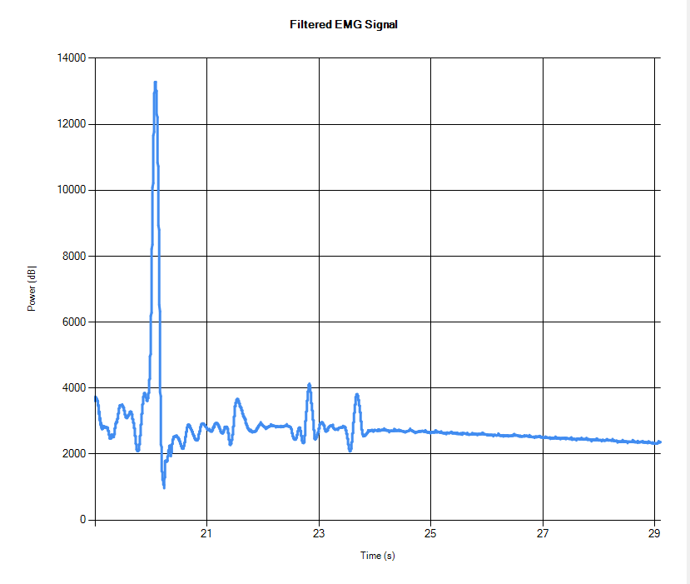

Figure 7.1: A sample white noise graph

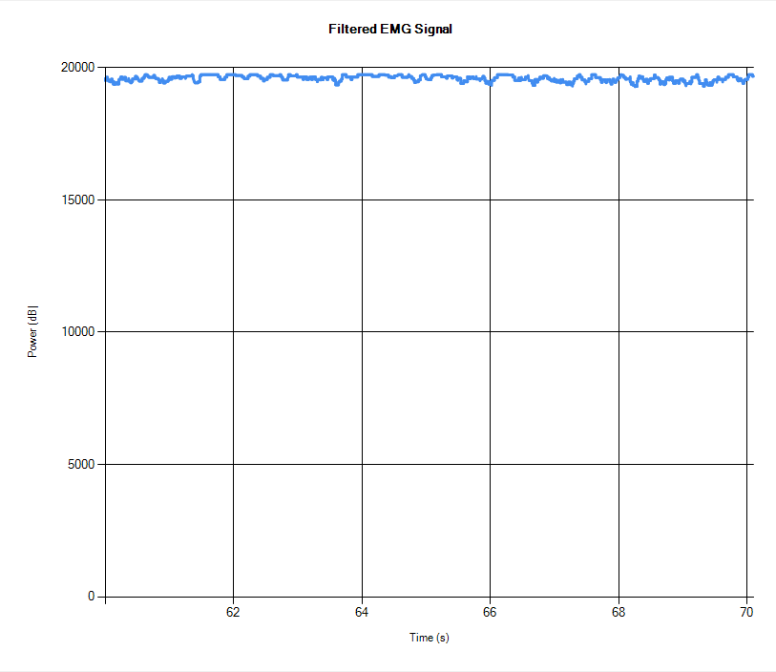

Figure 7.2: Touch one metal bar to skin (either one)

The IBT electrode is very sensitive to ambient noise if it’s not attached to skin. Even men-made air flow disturbance will be detected.

* 1. How to Design the Game for Mechanical Hand

Since the magnitude of EMG signal value is correlated to the motion speed of mechanical hand, the game design would be different with the Bar Control game in C# where the magnitude of EMG signal value is correlated to the position.

* 1. Metrics Design for Envelop Signal Analysis

It’s always an open question, as what kind of metrics for us to use to determine what kind of envelop signal is good or not. Currently we have rising time, variance, and throughput etc, are there anything else important? Also what’s the best way to calculate the normalized variance?

* 1. Experiment Design

It’s also always an open question, as how should we design the experiments or games to numerically prove that our electrodes perform as good as or even better than Ottobock electrodes?

1. Future Works
   1. Verify the unit of Raw EMG Signal transmitted from DAQ

One EMG data point is transmitted from the DAQ with through three separate bytes. After concatenating it become a 24-bit long signed value in two’s compliment representation. We are able to convert it into the readable value we want, but are still not very sure about the unit. It probably is in microvolt, but needs further verification.

* 1. Find out the source of large spikes and solve it
  2. Find out the reason of white noise and solve it
  3. Improve the FFT performance in C#

Right now the power spectrum result from C# looks different with that from Matlab. The reason could be that the FFT build-in function in Matlab is different from the FFT function I wrote in C#. So I am not recommending doing frequency analysis in C# for now until its performance is the same as that in Matlab.

* 1. Finish the human tests for EMG Game
     1. Possible Publication
  2. Design a game for mechanical hand experiments
     1. Possible Publication

1. Where and How to Find Pre-saved Test Data and Literatures

Everything is included in a folder named Hai Tang Documents.

* All the testing protocols, which include methods in docx files and preliminary data in xlsx files, are in Test Protocols folder.
* All the experiments data are saved in a folder named IBT Data, and the sub-folders are categorized by dates. Each figure has a unique name, so anyone could find the target figure by searching figure index. The figure indexes can be found in the experiments sheets in xlsx files mentioned above. The photos of experiments set up can be found in Photos for Setups folder.
* A daily working log which including daily thoughts and comments can be found in IBT Daily Tasks.docx and a note that includes steps for some experiments/tasks can be found in IBT Notes.docx. A simple User Manual for how to play my C# Game can be found in C# Hai_Game User Manual.docx. All of them are in My Report and Logs.
* The final version of C# Game code and Embedded C Filter Code are in folder named Final Version of Code.

Github Clone Links for C# Game Codes and Embedded C Filter Codes:

https://github.com/williamsea/EMG_Game_Csharp.git

https://github.com/williamsea/EMG_Project_Embedded_C.git

* All the related literatures are included in Papers.
* The schematics of the Custom Board, related Datasheets, and some Reports from Others can be found in corresponding folders.

1. References
2. De Luca, Carlo J. "Surface Electromyography: Detection and Recording." DelSys Incorporated. (2002)
3. Day, Scott. "Important Factors in Surface EMG Measurement." Bortec Biomedical.
4. Loeb, Gerald E., and Carl Gans. Electromyography for Experimentalists. Chicago: U of Chicago, 1986. Print.
5. Konrad, Peter. The ABC of EMG: A Practical Introduction to Kinesiological Electromyography. Tech. 2006. Print.
6. Williams, M.r., and R.f. Kirsch. "Evaluation of Head Orientation and Neck Muscle EMG Signals as Command Inputs to a Human–Computer Interface for Individuals With High Tetraplegia." IEEE Trans. Neural Syst. Rehabil. Eng. IEEE Transactions on Neural Systems and Rehabilitation Engineering 16.5 (2008): 485-96. Web.

Appendix

* 1. Embedded C Codes
     1. Block Diagram

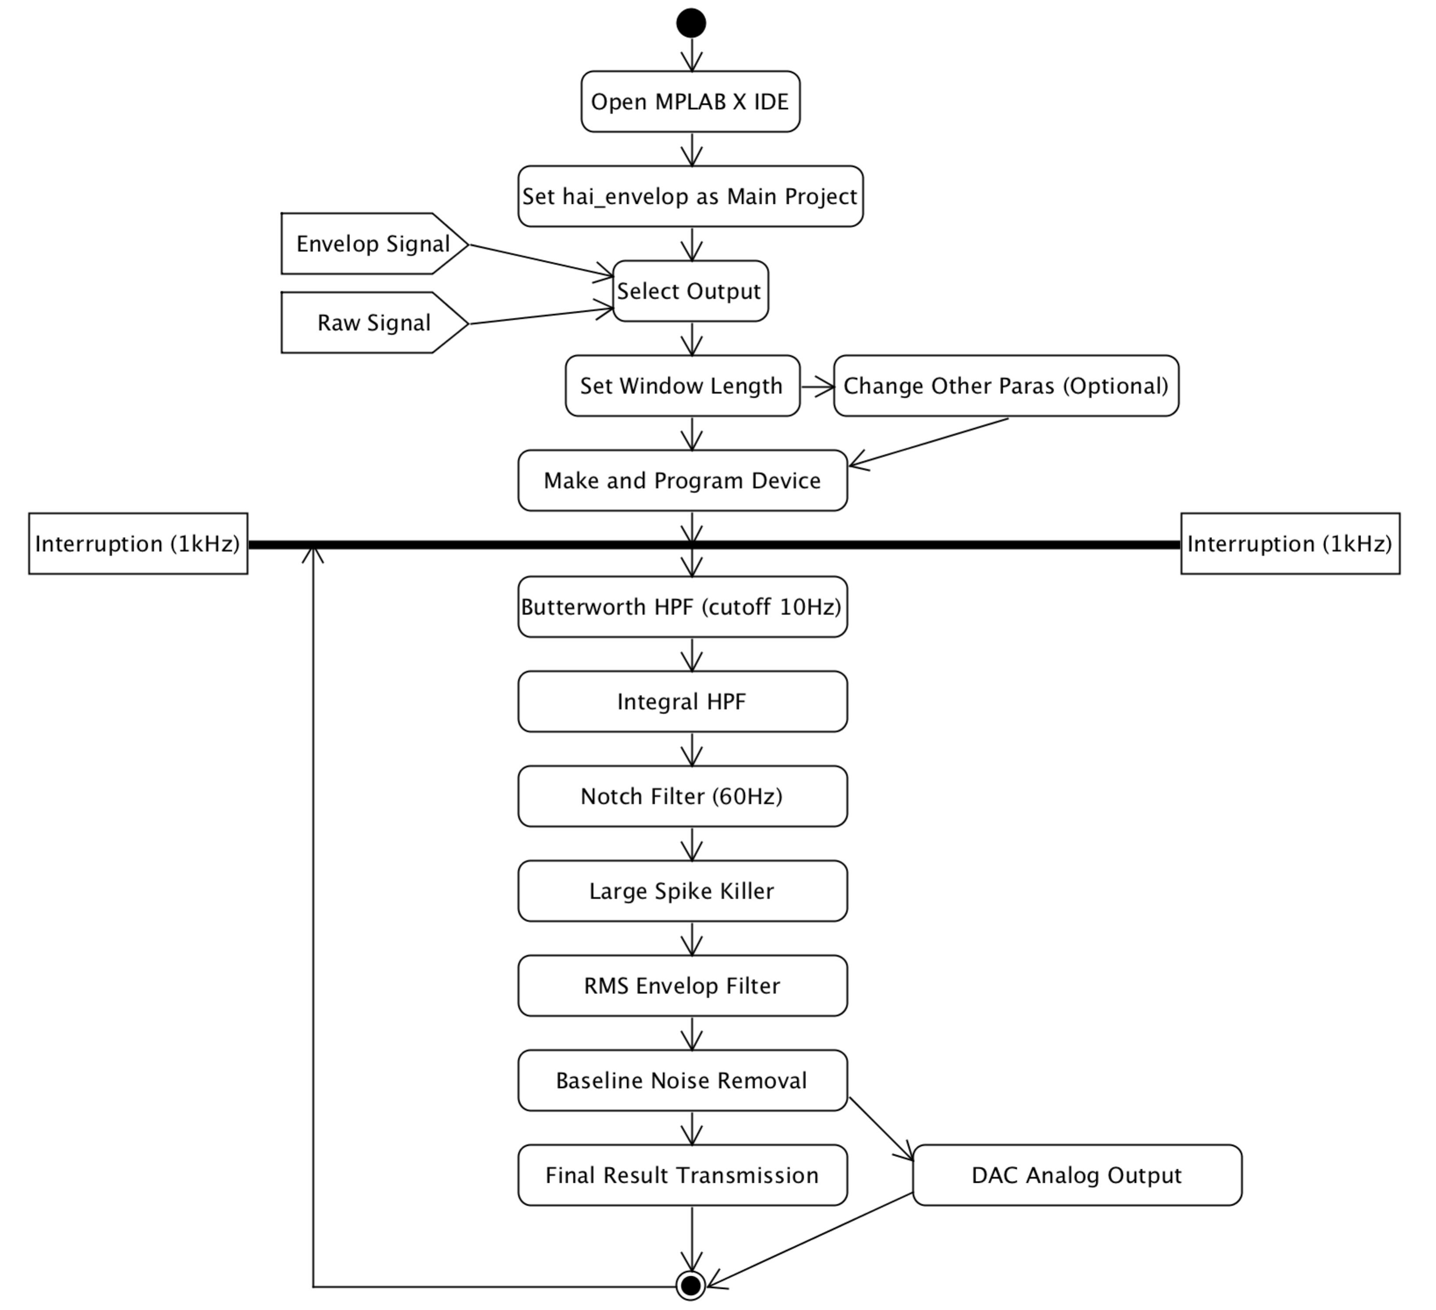

* + 1. Remarks
* Codes added or changed in hai_envelop project since Elliot_emg project include
* Output transmission selection added
* Integral HPF added
* Butterworth HPF cutoff value increased
* Large spike killer added
* RMS envelop filter added
* DAC output added
* To play the C# game, make sure to select envelop output (set txEnvelop = 1).
* To perform frequency analysis, make sure to select raw EMG output (set txEnvelop = 0).
* The unrelated codes are already all deleted.
* To use the Ottobock or LTI electrode, program the micro-controller with “LTI_OB_record” project.
  + 1. Source Code Location

C:\Users\Owner\MAPLABXProjects\hai_envelop.X

A full copy of all the methods not being used can be found in “ads_cntrl – Copy will ALL.c”.

* + 1. Key Functions Explanation

Detailed comments can be found in the code (ads_cntrl.c).

* 1. C# Game Codes
     1. Block Diagram

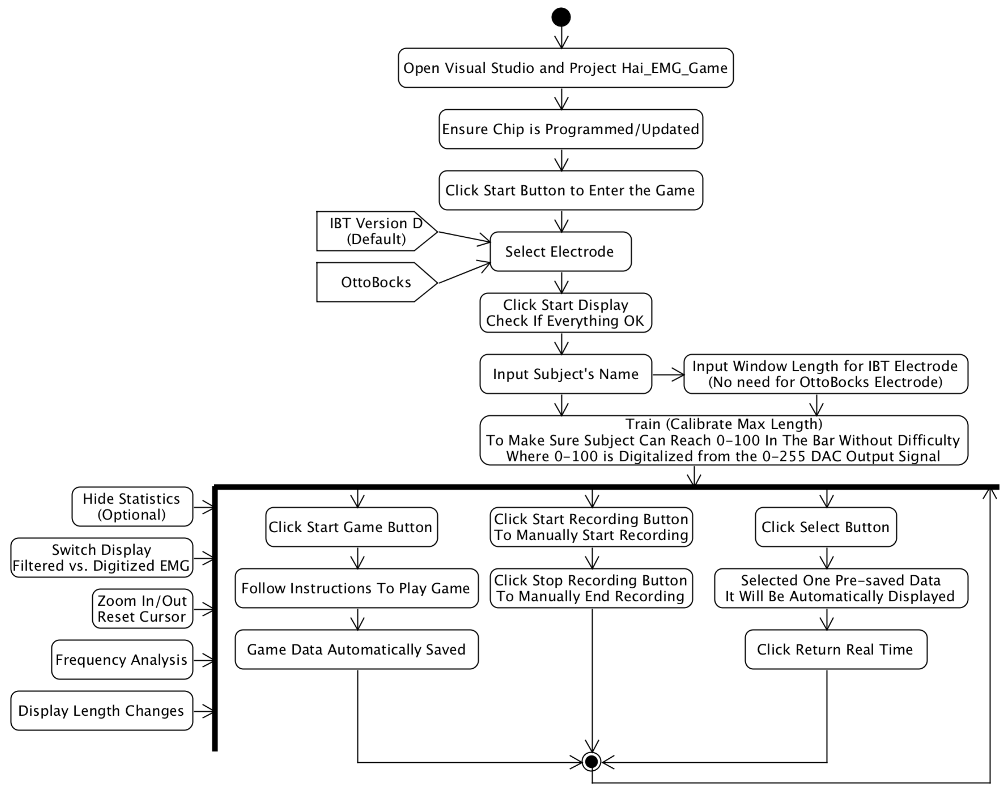

* + 1. Key Function Descriptions
       1. Form1.Load(): Initialization
       2. SerialPort_DataReceived()

This function is called every time there is new data come in through the Communication Port (COM2). A received buffer of size 500 is used to store the received data for future processing. In the function, the received data from DAQ board is processed to be meaningful EMG values, turning every [startingByte firstByte secondByte thirdByte endingByte] into one EMG value.

This function is also controlling the data recording, DAC (from 0-max to 0-255) and digitization (from 0-255 to 0-100) calculation.

And this function is used as an accurate timer as well, since it is called 1000 times every seconds, it provides us with a timer having high resolution (1ms) and precision. The build-in timer in C# has only 100ms resolution, which is not enough for parameter extractions like reaction time etc.

At last, this function is in charge of calculating the reaction time, count down/up timer, total time cost for hit, and number of hits.

* + - 1. DisplayData()

This function controls all the details of the display of EMG data and Game Bar in real time.

It is also in charge of calculating and recording of total hits number, total time cost for each hit, and throughput.

* + - 1. Timer_targetLevel_Tick()

This function controls the performance of target box, and the instructions between trials. And it handles what to do after the game finished, including saving all the data into a .txt file.

* + - 1. Read_txt()

This function extracts the data from one pre-saved .txt data file, excluding the statistics in the end of data file.

* + - 1. All kinds of Button_Click / timer_tick functions: Control what happen after clicking the target button or when the timer ticks.
    1. Where Are The Game Data Saved

The auto-saved game data and manually saved data are stored in Desktop/Game_Data. The subject’s name will be a sub-folder. And in the sub-folder are the data for each game or each manual saving, whose name convention is Date-Month-Year_Hour-Minute-Second.

* + 1. Source Code Location

C:\Users\Owner\Documents\Visual Studio 2015\ Projects\EMG_Game\Hai_EMG_Game\ Hai_EMG_Game

* 1. MATLAB Codes
     1. hai_emg_daq_general.m
        1. Description

This program is used to obtain a human forearm EMG data or simulated EMG data from IBT’s custom-made DAQ over a certain time period, which is a manually inputted parameter, in the unit of second. A 10-125 Hz band pass Butterworth filter and a 60 Hz Butterworth filter was originally included in this program. But since we’ve moved all the filtering to the embedded C code, the previous mentioned two filters are commented in this program.

* + - 1. Input
* The length of time *n* for a single measurement, in seconds
  + - 1. Output
* The Filtered Raw Data graph with a length of *n* seconds (*1000*n* data samples)
* The corresponding FFT Power Spectrum graph
  + - 1. Source Code Location

C:\User\Owner\Documents\Project-Electrode\Flex_Matlab\Testing Algos

* + 1. ManualSNRv2.m
       1. Description The new modifier hides a member of the base class. C# supports only hide by
       2. signature.

This program is used to calculate SNR of the obtained filtered EMG signal with a fixed time period. The number *N* of required samples of EMG signals and noises used to calculate the average is the only input parameter. The length *L* of a valid EMG signal and noise signal is firstly selected, and then select the starting points of *N* representative clean EMG signals and then *N* representative stable noise signals, which will have length *L*. And finally the average SNR based on the amplitude of signals is calculated.

* + - 1. Input
* The number *N* of required samples of EMG signals and noises used to calculate the average.
  + - 1. Output
* SNR value, in dB, showing in Matlab command window
  + - 1. Source Code Location

C:\User\Owner\Documents\Project-Electrode\Flex_Matlab\Testing Algos

* + 1. hai_emg_daq_envelop.m
       1. Description

This program is used to obtain EMG envelope data and its derivative from IBT’s custom-made DAQ over a certain time period.

* + - 1. Input
* The length of time n for a single measurement, in seconds
  + - 1. Output
* The envelop signal graph with length *n* seconds (*1000*n* data samples).
* The first derivative graph of the envelop signal.
  + - 1. Source Code Location

C:\User\Owner\Documents\Project-Electrode\Flex_Matlab\Testing Algos\Hai_Envelop

* + 1. hai_MeasureAll.m
       1. Description

This code is used when you’ve already obtained the measured envelop signal in Matlab, and want to analyze its rising time, normalized variance, average signal magnitude and average noise magnitude etc.

The user will be asked to firstly select the starting and ending position of the rising edges of *npeak* (a user selected number) signals. And the averaged rising time will be calculated and shown in the commend window.

Then the user will be asked to *npeak* EMG signals by selecting the starting and ending position of the signals in sequence. The mean signal magnitude will be shown after selection finishes.

Afterwards the user will be asked to select the starting and ending points for a typical noise (usually the noise is 0 for envelop, since the signal is filtered and processed). The man noise magnitude will be shown after selection.

And at last the normalized variance is calculated by

*norm_signal = (signal – mean_signal)/(mean_signal – mean_noise)*

*norm_variance = var(norm_signal)*

* + - 1. Input
* *Npeaks*, which is the user selected number of data sets (signal and noise set) used for averaging.
  + - 1. Output
* Average Rising Time
* Normalized Variance
* Mean Signal Magnitude
* Mean Noise Magnitude
  + - 1. Source Code Location

C:\User\Owner\Documents\Project-Electrode\Flex_Matlab\Testing Algos\Hai_Envelop